**VIVEKANAND EDUCATION SOCIETY’S INSTITUTE OF TECHNOLOGY**

**An Autonomous Institute Affiliated to University of Mumbai**

**Department of Computer Engineering**



Project Report on

**Package Delivery: One stop solution for delivery**

In partial fulfillment of the Fourth Year, Bachelor of Engineering (B.E.) Degree in Computer Engineering at the University of Mumbai

Academic Year 2023-24

**Submitted by**

Niranjan Yeole (D17 - C , Roll no - 60 )

Aayushi Salunkhe (D17 - C , Roll no - 50 )

Aarya Lotke (D17 - C , Roll no - 30 )

Bhargav Mungekar (D17 - C , Roll no - 37 )

**Project Mentor**

Dr. Gresha Bhatia

(2023-24)

**VIVEKANAND EDUCATION SOCIETY’S INSTITUTE OF TECHNOLOGY**

**An Autonomous Institute Affiliated to University of Mumbai**

**Department of Computer Engineering**



**Certificate**

This is to certify that **Bhargav Mungekar(D17C/37), Niranjan Yeole(D17C/60), Aayushi Salunkhe(D17C/50), Aarya Lotke(D17C/30)**of Fourth Year Computer Engineering studying under the University of Mumbai have satisfactorily completed the project on “**Package Delivery: One stop solution for delivery**” as a part of their coursework of PROJECT-II for Semester-VIII under the guidance of their mentor **Dr. Gresha Bhatia**in the year 2023-24 .

This project report entitled **Package Delivery: One stop solution for delivery** by **Bhargav Mungekar, Niranjan Yeole, Aayushi Salunkhe, Aarya Lotke** is approved for the degree of **B.E. Computer engineering**.

| Programme Outcomes | Grade |
| --- | --- |
| PO1,PO2,PO3,PO4,PO5,PO6,PO7,  PO8, PO9, PO10, PO11, PO12  PSO1, PSO2 |  |

Date:

Project Guide:

------------------------------------------

**Project Report Approval**

**For**

**B. E (Computer Engineering)**

This project report entitled **Package Delivery: One stop solution for delivery** by **Bhargav Mungekar(D17C/37), Niranjan Yeole(D17C/60), Aayushi Salunkhe(D17C/50), Aarya Lotke(D17C/30)** is approved for the degree of **B.E. Computer Engineering.**

Internal Examiner

---------------------------------------------

External Examiner

---------------------------------------------

Head of the Department

-----------------------------------------------

Principal

-----------------------------------------------

Date:

Place: Mumbai

**Declaration**

We declare that this written submission represents our ideas in our own words and where others' ideas or words have been included, we have adequately cited and referenced the original sources. We also declare that we have adhered to all principles of academic honesty and integrity and have not misrepresented or fabricated or falsified any idea/data/fact/source in our submission. We understand that any violation of the above will be cause for disciplinary action by the Institute and can also evoke penal action from the sources which have thus not been properly cited or from whom proper permission has not been taken when needed.

| -----------------------------------------  Bhargav Mungekar (D17C/37) | -----------------------------------------  Niranjan Yeole (D17C/60) |
| --- | --- |
| -----------------------------------------  Aayushi Salunkhe (D17C/50) | -----------------------------------------  Aarya Lotke (D17C/30) |

Date:

**ACKNOWLEDGEMENT**

We are thankful to our college Vivekanand Education Society’s Institute of Technology for considering our project and extending help at all stages needed during our work of collecting information regarding the project.

It gives us immense pleasure to express our deep and sincere gratitude to project mentor **Dr.(Mrs). Gresha Bhatia** for her kind help and valuable advice during the development of project synopsis and for her guidance and suggestions.

We are deeply indebted to Head of the Computer Department **Dr.(Mrs.) Nupur Giri** and our Principal **Dr. (Mrs.) J.M. Nair ,** for giving us this valuable opportunity to do this project.

We express our hearty thanks to them for their assistance without which it would have been difficult in finishing this project synopsis and project review successfully.

We convey our deep sense of gratitude to all teaching and non-teaching staff for their constant encouragement, support and selfless help throughout the project work. It is a great pleasure to acknowledge the help and suggestion, which we received from the Department of Computer Engineering.

We wish to express our profound thanks to all those who helped us in gathering information about the project. Our families too have provided moral support and encouragement several times.

**Computer Engineering Department**

**COURSE OUTCOMES FOR B.E PROJECT**

Learners will be to,

| **Course Outcome** | **Description of the Course Outcome** |
| --- | --- |
| CO 1 | Able to apply the relevant engineering concepts, knowledge and skills towards the project. |
| CO2 | Able to identify, formulate and interpret the various relevant research papers and to determine the problem. |
| CO 3 | Able to apply the engineering concepts towards designing solutions for the problem. |
| CO 4 | Able to interpret the data and datasets to be utilized. |
| CO 5 | Able to create, select and apply appropriate technologies, techniques, resources and tools for the project. |
| CO 6 | Able to apply ethical, professional policies and principles towards societal, environmental, safety and cultural benefit. |
| CO 7 | Able to function effectively as an individual, and as a member of a team, allocating roles with clear lines of responsibility and accountability. |
| CO 8 | Able to write effective reports, design documents and make effective presentations. |
| CO 9 | Able to apply engineering and management principles to the project as a team member. |
| CO 10 | Able to apply the project domain knowledge to sharpen one’s competency. |
| CO 11 | Able to develop a professional, presentational, balanced and structured approach towards project development. |
| CO 12 | Able to adopt skills, languages, environment and platforms for creating innovative solutions for the project. |

**Index**

| Chapter No. | Title | Page  No. |
| --- | --- | --- |
|  | **Abstract** | 9 |
| **1.** | **Introduction** | 10 |
| 1.1 | Introduction | 10 |
| 1.2 | Motivation | 10 |
| 1.3 | Problem Definition | 12 |
| 1.4 | Existing Systems | 13 |
| 1.5 | Lacuna of the Existing Systems | 14 |
| 1.6 | Relevance of the Project | 14 |
| **2.** | **Literature Survey** | 16 |
| A | Brief overview of Literature Survey | 16 |
| B | Related Works | 16 |
| 2.1 | Research Papers | 16 |
| 2.2 | Patent search | 20 |
| 2.3 | Inference Drawn | 21 |
| 2.4 | Comparison with the Existing Systems | 22 |
| **3.** | **Requirement Gathering for the proposed System** | 23 |
| 3.1 | Introduction to Requirement Gathering | 23 |
| 3.2 | Functional Requirements | 23 |
| 3.3 | Non-Functional Requirements | 24 |
| 3.4 | Hardware, Software, Technology and tools utilized | 25 |
| 3.5 | Constraints | 26 |
| **4.** | **Proposed Design** | 27 |
| 4.1 | Block diagram of the system | 27 |
| 4.2 | Modular design of the system | 28 |

| 4.3 | Detailed Design | 29 |
| --- | --- | --- |
| 4.4 | Project Scheduling &amp; Tracking using Timeline / Gantt Chart | 33 |
| **5.** | **Implementation of the Proposed System** | 34 |
| 5.1 | Methodology employed for development | 34 |
| 5.2 | Algorithms and flowcharts for the respective modules developed | 34 |
| **6.** | **Testing of the Proposed System** | 37 |
| 6.1 | Introduction to testing | 37 |
| 6.2 | Types of tests Considered | 37 |
| 6.3 | Various test case scenarios considered | 38 |
| 6.4 | Inference drawn from the test cases | 40 |
| **7.** | **Results and Discussions** | 41 |
| 7.1 | Screenshots of User Interface (UI) for the respective module | 41 |
| 7.2 | Performance Evaluation measures | 43 |
| 7.3 | Input Parameters / Features considered | 43 |
| 7.4 | Graphical and statistical output | 45 |
| 7.5 | Comparison of results with existing systems | 47 |
| 7.6 | Inference drawn | 48 |
| **8.** | **Conclusion** | 49 |
| 8.1 | Limitations | 49 |
| 8.2 | Conclusion | 49 |
| 8.3 | Future Scope | 50 |
|  | **References** | 51 |
|  | **Appendix** | 53 |
| 1 | Proposed Patent | 53 |
| 2 | Competition certificates | 55 |
| 3 | Project review sheet | 57 |

**List of figures**

| Fig No. | Heading | Page No. |
| --- | --- | --- |
| 1 | Block Diagram | 27 |
| 2 | Modular Diagram | 28 |
| 3 | DFD Level 0 | 29 |
| 4 | DFD Level 1 | 31 |
| 5 | Entity-relationship diagram (ERD) | 32 |
| 6 | Gantt Chart | 33 |
| 7 | Order Placement | 35 |
| 8 | Order Acceptance | 36 |
| 9 | Manual Test Cases : Order Placing Phase | 40 |
| 10 | Manual Test Cases : Order Acceptance Phase | 40 |
| 11 | Admin Dashboard - Home Page | 45 |
| 12 | Admin Dashboard - List of contacts | 45 |
| 13 | Firestore Statistics | 46 |

**List of tables**

| Fig No. | Heading | Page No. |
| --- | --- | --- |
| 1 | Comparison with existing system | 47 |

**Abstract**

Traditional package shipping services often come with high costs, prompting the exploration of alternative methods to enhance affordability and efficiency. This study introduces a novel concept that harnesses the potential of traveler collaboration to facilitate cost-effective package delivery. When a sender intends to dispatch a package from location A to destination B, this approach enables them to identify a traveler heading to the same destination.

Through a dedicated mobile application called **DeliveryX**, the sender can seamlessly connect with the traveler and arrange for the package to be transported alongside the traveler's belongings. This mutually beneficial arrangement not only offers significant cost savings compared to conventional shipping services but also provides an earning opportunity for the traveler.

**Chapter 1: Introduction**

**1.1 Introduction**

In an era characterized by the fusion of technology and convenience, package shipping has emerged as a cornerstone of modern life. Whether it's sending a heartfelt gift, dispatching vital business documents, or delivering everyday essentials, we rely heavily on domestic parcel shipping services to bridge the geographical divide. Nonetheless, this convenience often comes at a steep financial cost, leaving both senders and recipients grappling with the financial ramifications of shipping, and limiting the diversity of courier choices available.

As a response to these issues, this study introduces an avant-garde mobile application project that confronts these dilemmas head-on. The crux of the project revolves around two pivotal goals: lowering the overall cost of shipping and broadening the spectrum of potential couriers. It achieves this by leveraging the collective potential of travelers and individuals who share common routes. Through this endeavor, senders can establish connections with those journeying in the same direction, tapping into the previously untapped resource of unused cargo space in their vehicles. The result is an innovative, cost-effective, and accessible alternative to traditional parcel shipping services.

The landscape of domestic parcel shipping is in need of transformation, and this project is a resolute response to these challenges. It aspires to revolutionize the way packages are shipped domestically, offering an affordable and sustainable solution that empowers both individuals and businesses. The inherent potential of connecting senders with like-minded travelers promises a future where cost-efficiency, accessibility, and sustainability converge to meet the evolving demands of our interconnected world. In this paper, we delve deeper into the motivations, design principles, and potential implications of this groundbreaking mobile application project.

**1.2 Motivation**

The motivation behind this project is deeply rooted in the existing inadequacies and inefficiencies within the domestic parcel shipping industry. These motivating factors include:

**1.2.1 Escalating Shipping Costs:** Shipping costs within a domestic context have steadily risen over the years, creating a financial barrier for both individuals and businesses. The primary motivation for this project is to provide a cost-effective alternative that significantly reduces the financial burden on senders and recipients.

**1.2.2 Environmental Responsibility:** The growing concerns regarding environmental sustainability and carbon emissions associated with the shipping industry drive the motivation to create a more eco-friendly alternative. By optimizing the use of existing transportation routes and reducing the number of dedicated delivery vehicles on the road, this project aligns with the imperative of reducing our carbon footprint.

**1.2.3 Resource Optimization:** In an era where efficiency and resource optimization are paramount, the project seeks to capitalize on the untapped potential of unused cargo space in vehicles already headed in the same direction. This resource optimization not only decreases costs but also minimizes waste and contributes to a more efficient system.

**1.2.4 Diversity of Couriers:** The existing domestic shipping services often lack diversity in courier options. This project's motivation lies in diversifying the range of available couriers by engaging a network of willing travelers and individuals. It provides senders with a broader spectrum of choices, enhancing flexibility and convenience.

**1.2.5 Empowering Local Communities:** The project aims to strengthen local communities by fostering connections within them. By creating a platform that encourages collaboration and mutual assistance, it empowers individuals and small businesses, supporting local economies and social connections.

**1.2.6 Meeting Evolving Demands:** The motivation for this project is rooted in the recognition of the evolving demands of our interconnected world. In an age marked by e-commerce and instant gratification, the project aims to offer a solution that aligns with these changing expectations, providing a more responsive and convenient means of domestic parcel shipping.

The motivation, therefore, is to address these multifaceted challenges and offer a revolutionary solution that doesn't just reduce costs but also promotes environmental sustainability, optimizes resources, diversifies courier options, empowers local communities, and aligns with the changing dynamics of the modern world. By connecting senders with willing travelers and individuals heading in the same direction, this project aspires to reshape and invigorate the domestic parcel shipping landscape, offering an affordable, accessible, and efficient solution to meet the evolving demands of our interconnected society.

**1.3 Problem Definition**

In today's world, the issue of expensive and unreliable package shipments is not confined to international logistics; it extends to the local and domestic parcel shipping services within a country. This issue is marked by two fundamental challenges:

**1.3.1 High Costs:**

- Domestic Level: Even within the borders of a single country, sending packages can be prohibitively expensive. This high cost of domestic parcel shipping places a substantial financial burden on both individual senders and small enterprises. The expenses associated with shipping can deter people from utilizing these services, especially for frequent or large shipments.

- International Level: The problem of exorbitant costs is further exacerbated when shipping packages internationally. The fees associated with sending items abroad are often considerably higher than domestic shipping costs. This financial barrier not only impacts individuals but also imposes a significant financial burden on businesses engaged in international trade and commerce.

**1.3.2. Reliability Issues:**

- Domestic Level: Even within the same country, domestic package shipping services can sometimes be marked by unreliability. This unreliability encompasses delays in delivery, misrouting of packages, and a lack of transparency in tracking and communication. Such issues can be particularly troublesome for businesses that rely on timely deliveries to meet customer expectations.

- International Level: Similarly, the issue of reliability extends to international shipments. The variability in customs procedures, the potential for lost or damaged items, and the lack of real-time tracking can make international shipping a risky endeavor. This unreliability affects not only the sender's peace of mind but also the reputation of the shipping service provider.

Addressing these problems at a domestic level is not just a localized solution; it also lays the foundation for tackling international shipping challenges. By developing a more efficient, cost-effective, and reliable domestic parcel shipping system, we create a template that can be adapted and expanded to international shipping, ultimately addressing the global issue of expensive and unreliable package shipment.

In summary, the issues of high costs and reliability in package shipping exist both at the local and international levels. High costs burden both senders and recipients, making shipping financially challenging. Reliability issues, such as delays and misrouting, add to the frustration of users. By addressing these problems domestically, we can create a scalable solution that not only eases the local burden but also paves the way for more effective and economical international package shipping services.

**1.4 Existing Systems**

Package Delivery Applications -

**1.4.1. Borzo:**

Borzo is a courier service application of India which is budget centered and is getting very popular in the market these days because of its fast delivery and low-cost services. Borzo uses a B2C model and focuses on time managing delivery. It provides same day on demand intra-city courier and express delivery service in 60-90 minutes exactly when you need it. Place an order in this delivery app and the system will find the most suitable delivery partner nearby. It currently operates in 8 cities in India including Mumbai, Delhi/NCR, Hyderabad, Chennai, Ahmedabad, Kolkata, Pune and Bengaluru. Borzo has two different applications: One for the customer end and Second for the delivery end.

**1.4.2. Pidge:**

Pidge is an on-demand courier delivery service currently active only in the Delhi NCR region. It provides an eCommerce courier delivery service for different types of businesses.

**1.4.3. Dunzo:**

Dunzo is also an app-based courier delivery service provider with a similar business model to WeFast. In fact, Dunzo is one of the most popular courier service delivery apps functioning in the market. Suppose you own a business and are looking for a hyperlocal delivery partner to either buy daily stuff or to outsource delivery service for your products, Dunzo is a good option. Dunzo has even partnered with local restaurants to offer food delivery services just like Swiggy and Zomato. Dunzo operates in the following cities: Mumbai, Pune, Bangalore, Chennai, Hyderabad, Jaipur, New Delhi, Gurgaon.

**1.4.4. Saral:**

Saral is an application based, same-day, intra-city delivery service provider by India’s leading E-Commerce shipping company Shiprocket. It delivers the parcels within a 50-kilometer radius. It is available on Android (Play store) and IOS (App store). Saral has partnered with many delivery services like Shadowfax, Dunzo and Wefast and offers its services in 12 cities including Delhi, Bangalore, Ahmedabad, Chennai, Jaipur, Faridabad, Mumbai, Hyderabad, Navi Mumbai, Gurgaon, Pune, and Noida.

**1.5 Lacuna in the existing system**

**High Sender-Side Delivery Costs:**

* The existing package delivery system often incurs high costs for the sender due to fixed pricing structures.
* These costs can be a deterrent, particularly for individuals and small businesses looking for affordable delivery options.

**Limited Pool of Professional Delivery Personnel:**

* The current system primarily relies on professional delivery personnel employed by delivery companies.
* This limitation restricts the potential pool of available couriers, ignoring the possibility of using travelers or individuals going in the same direction.

**1.6 Relevance of the Project**

The relevance of this project lies in its potential to revolutionize the traditional package shipping services, which have long been plagued by high costs and inefficiencies. By introducing the concept of traveler collaboration, it offers a fresh approach that can enhance both the affordability and efficiency of package delivery. This innovative solution allows senders to identify travelers heading to the same destination and arrange for their packages to be transported alongside the traveler's belongings, creating a mutually beneficial arrangement. Not only does this concept significantly reduce the financial burden on senders compared to conventional shipping services, but it also presents an earning opportunity for the travelers, adding to its relevance in today's economy.

Furthermore, the project's emphasis on leveraging a dedicated mobile application aligns with the modern technological landscape, making it highly relevant in a digitally connected world. This technology-driven approach streamlines the entire process of package delivery, providing a user-friendly and practical solution for both senders and travelers. By focusing on affordability and practicality, the project directly addresses the economic challenges that individuals and businesses face, enhancing its relevance in an era where cost-effective alternatives and efficient services are highly sought after. In conclusion, this project's relevance lies in its potential to disrupt the conventional package shipping industry, offering a solution that is cost-effective, efficient, and technologically advanced, benefiting both senders and travelers in a mutually advantageous manner.

**Chapter 2: Literature Survey**

1. **Brief Overview of Literature Survey**

The research papers cover topics such as challenges in Indian courier services, innovations in home delivery, management analysis of Uber, and case studies of successful express logistics companies. They provide insights into improving service delivery, addressing emerging needs, understanding disruptive business models, and identifying strategies for success in the logistics industry.

1. **Related works**

**2.1 Research Papers Referred**

1. **S. Anvekar, “Courier Services in India: Concerns for Effective Service Delivery”, UJBM, vol. 6, no. 2, pp. 83-90, Jun. 2007.**
2. **Abstract:** The courier industry in India is like a vital link of communication between persons and corporations meant for individual and industrial benefits. It is an industry worth Rs. 50 billion and is on a steady pace of development. More than 2300 courier companies operating in India, it is a challenge for the service provider of courier services to be unique, competent and provide effective service delivery.

An insight into the crucial and critical incidents of service failure and strategizing by closing these failures will ensure effective service deliveries by the courier service providers. A trained and skilled front stage personnel, committed delivery boys/runners and efficient distribution networking can enable the courier service operators to provide failure free effective service delivery.

1. **Inference:**

Significance of the Courier Industry: The courier industry plays a crucial role in facilitating communication between individuals and businesses in India. It is described as a vital link, indicating its importance for both personal and industrial purposes.

Economic Value: The industry is substantial in terms of its economic worth, amounting to Rs. 50 billion. This suggests that it is a significant contributor to the Indian economy.

Industry Size and Competition: With over 2300 courier companies operating in India, the industry is highly competitive. This indicates a crowded market where differentiation and quality of service are essential for success.

Continuous Growth: Despite the competitive landscape, the courier industry is experiencing steady growth. This implies that there is demand for courier services and opportunities for expansion within the market.

Challenges in Service Provision: Given the competitive nature of the industry, providing unique and effective services is a challenge for courier service providers. This suggests that differentiation strategies are crucial for success.

Focus on Service Quality: The paper emphasizes the importance of effective service delivery and highlights the significance of addressing service failures. This indicates a focus on customer satisfaction and the need for strategies to ensure service reliability.

Key Factors for Effective Service Delivery: The paper suggests that trained personnel, committed delivery personnel, and efficient distribution networks are critical for ensuring failure-free service delivery. This implies that investments in human resources and infrastructure are essential for operational excellence in the courier industry.

1. **Ghajargar, Maliheh & Zenezini, Giovanni & Montanaro, Teodoro. (2016). Home delivery services: innovations and emerging needs. IFAC-PapersOnLine. 49. 1371-1376. 10.1016/j.ifacol.2016.07.755.**
2. **Abstract:** The increasing amount of small-sized shipments and their frequency variation, due to the growth of e-commerce, pose a great challenge to logistics service providers. At the same time, new technologies and innovations are being developed with the aim of increasing the efficiency of logistics service providers, as well as fostering the creation of new enterprises and business models in the home delivery sector. The aim of this paper is to provide an exploratory analysis of the fit between existing home delivery innovative services, requirements, and issues that users might have. To do so, we review the main features of innovative services and we compare them with the findings from an online survey. For each service, we identify the value propositions, and the issues the service aims to address. In particular, four innovative services are reviewed. Through the online survey, we identify user’s habits, requirements and perceptions regarding the effectiveness and features of the innovative services.
3. **Inference:**

Impact of E-commerce Growth: The paper highlights the challenge posed to logistics service providers by the increasing volume and variability of small-sized shipments, primarily driven by the growth of e-commerce. This suggests that the rise of online shopping is reshaping the logistics landscape, demanding more flexible and efficient solutions.

Role of Technology and Innovation: To address the challenges posed by e-commerce growth, logistics service providers are turning to new technologies and innovations. This indicates a recognition of the need for technological advancements to improve efficiency and adapt to changing market demands.

Emergence of New Business Models: The paper suggests that the development of new technologies not only aims to enhance the efficiency of existing logistics services but also facilitates the creation of new enterprises and business models, particularly in the home delivery sector. This implies that technological innovations are driving entrepreneurship and reshaping the competitive landscape.

Identification of Value Propositions and Issues: The study aims to identify the value propositions offered by innovative home delivery services and the specific issues they aim to address. This indicates a focus on understanding the unique selling points of these services and their potential to meet user needs.

1. **Kumari, Amisha & Sharma, Samridhi. (2019). Management Analysis of Uber. 10.13140/RG.2.2.35129.93284.**
2. **Abstract:** Uber Technologies, Inc. is an American multinational transportation network company (TNC) offering services that include peer-to-peer ridesharing, ride service hailing, food delivery, and a bicycle-sharing system. The company is based in San Francisco and has operations in 785 metropolitan areas worldwide. Its platforms can be accessed via its websites and mobile apps. This project includes the evolution of Uber, its working and management strategy, success stories, financial statistics, SWOT and PESTLE analysis, setbacks faced and updated policies, based on the studies conducted in this field.
3. **Inference:**

User-Centric Growth Strategy: Uber's growth strategy focused on addressing key challenges faced by users, particularly in terms of cost and convenience. This suggests that the company prioritized understanding user needs and developing solutions to enhance the overall user experience.

Startup Lessons Learned: Uber's journey provides valuable startup lessons, including the importance of proactively addressing scandals. This indicates that the company recognized the significance of managing reputation and public perception to maintain trust and credibility.

Emphasis on Simplicity: Another lesson learned from Uber's experience is the importance of simplicity in product and service offerings. This implies that Uber recognized the value of user-friendly interfaces and straightforward processes in attracting and retaining customers.

Decentralization: Uber's approach also underscores the significance of decentralization in its operations. This suggests that the company adopted a distributed model that empowered local teams to make decisions and tailor services to specific markets, fostering agility and responsiveness.

1. **Ling, Tan & Lee, C. & Ho, William. (2009). The analysis and case studies of successful express logistics companies. International Journal of Value Chain Management. 3. 10.1504/IJVCM.2009.022415.**
2. **Abstract:** With the globalization of world business, the border-crossing activities between organizations have substantially increased. Organizations not only need to handle supply functions, but also play a tremendous role in demand simulation through integration both inside the firm and outside with business partners and customers. Logistics has become more and more mature and sophisticated by taking on an external focus, incorporating suppliers and customers in the business processes, with all the supply chain functions integrated into a whole. By minimizing the costs in the value chain or providing customized services, logistics acts as a major source of competitive advantages and profitability. To meet this goal, it would require the integration of activities to focus on customer-oriented measures. Customer service and logistics activities are a chain of interdependent activities that supplement each other to facilitate the flow of information, goods and cash within the value chain. The absence of one activity may imply some specific channels need to supplement another unit. Generally, this paper is to study the impact of corporate strategy, technology and customer satisfaction on the firm's performance, filling the gap of good customer service effects on long-term profits. Two international delivery providers, UPS and FedEx, are studied to realize the critical success factors of express logistics.
3. **Inference:**

Globalization and Border-Crossing Activities: The increasing globalization of business has led to a rise in border-crossing activities between organizations. This suggests that companies are operating in a more interconnected and interdependent global marketplace, necessitating efficient management of supply and demand functions across borders.

Integration of Supply Chain Functions: Logistics has evolved to become more mature and sophisticated, with a focus on external integration by incorporating suppliers and customers into business processes. This indicates a shift towards holistic supply chain management, where all functions are integrated to optimize efficiency and effectiveness.

Role of Logistics in Competitive Advantage: Logistics plays a crucial role in providing competitive advantages and enhancing profitability by minimizing costs in the value chain and offering customized services. This suggests that companies can gain a competitive edge by optimizing their logistics operations to meet customer needs effectively.

Interdependence of Customer Service and Logistics Activities: Customer service and logistics activities are depicted as interdependent activities that complement each other within the value chain. This suggests that seamless coordination between these activities is essential to facilitate the flow of information, goods, and cash within the value chain.

**2.2 Patent Search**

**2.2.1 Multi Stage Parcel Tracking System :** A delivery tracking system capable of tracking parcels during an internal stage of delivery within an organization after receipt of the parcel from a parcel delivery service. The system utilizes an intelligent, hand-held, portable data entry and data processing device to obtain signatures of recipients and scan codes printed on parcel labels, and to respond to tracking inquiries prior to transferring collected information to a different computer. Data is entered on a touch-sensitive screen of a personal digital assistant using the tip of a wand-type barcode scanner.

**2.2.1 Multi-tiered parcel sortation system:** A multi-tiered automated parcel sortation system is utilized to sort parcels according to a common destination. A first tier includes an automated sorter configured to transport parcels from a source location to a release destination. A second tier includes accumulation containers each associated with a shipping destination, and the release destination within the first tier is positioned directly above the accumulation container associated with the shipping destination of the parcel. Once transported to the release destination, a parcel is released into the accumulation container, and once the accumulation container is filled, the accumulation of parcels within the container is released into a third tier, which may include conveyors or autonomous guided vehicles with transport containers. In the third tier, the parcels are transported away for further processing.

**2.3 Inference drawn**

Efficiency in Parcel Handling: Both patents indicate a focus on improving efficiency in parcel handling within an organization. The multi-stage parcel tracking system aims to streamline internal delivery processes, while the multi-tiered parcel sortation system seeks to automate the sorting process to enhance efficiency.

Integration of Technology: The patents illustrate the integration of advanced technology into parcel handling operations. The use of handheld devices with barcode scanners in the tracking system and automated sortation systems in the sorting system reflects a commitment to leveraging technology for improved performance.

Optimization of Internal Logistics: The multi-tiered parcel sortation system suggests a strategic approach to internal logistics management. By sorting parcels according to common destinations and employing automated sorting mechanisms, the system aims to optimize the flow of parcels within the organization, reducing bottlenecks and minimizing handling time.

Continuous Improvement: The patents suggest a commitment to continuous improvement in parcel handling processes. By investing in innovative technology and refining operational workflows, the organization aims to enhance efficiency, accuracy, and overall customer experience in parcel delivery and tracking.

**2.4 Comparison with the existing system**

| **Existing System** | **Solutions through DeliveryX** |
| --- | --- |
| High delivery costs for senders | Solution: Empowering anyone to become a courier can create a more cost-effective alternative for senders, as travelers can deliver packages along their routes at a lower cost. |
| Limited geographic coverage | Solution: Your project can extend the coverage by leveraging travelers from various locations, even in remote areas, where traditional services may not operate. |
| Lack of pricing transparency | Solution: Implement transparent pricing structures and competitive pricing models that benefit both senders and travelers, eliminating hidden fees and unexpected costs. |
| Inconsistent delivery times | Solution: By engaging a network of traveler-couriers, you can offer more flexible delivery windows, which may lead to faster and more reliable delivery times. |

Table 1: Comparison with existing system

**Chapter 3: Requirement gathering for the proposed system**

**3.1 Introduction to requirement gathering**

The Requirement Gathering is a process of requirements discovery or generating list of requirements or

collecting as many requirements as possible by end users. It is also called as requirements elicitation or

requirement capture.

The requirements gathering process consists of six steps :

● Identify the relevant stakeholders

● Establish project goals and objectives

● Elicit requirements from stakeholders

● Document the requirements

● Confirm the requirements

● Prioritize the requirements

**3.2 Functional Requirements**

1. User Registration and Authentication:

Allow users to create accounts and log in securely using email, phone, or social media accounts.

1. Sender Functionality:
2. Senders should be able to create and schedule package deliveries.
3. Specify package details (size, weight, special handling instructions).
4. Set delivery preferences (time, speed, and cost).
5. Track package status and receive notifications.
6. Traveler Functionality:
7. Travelers should be able to view available delivery requests.
8. Accept or decline delivery requests.
9. Access package details and sender instructions.
10. Communicate with senders and recipients.
11. Package Matching and Assignment:
12. Implement an algorithm to match senders with suitable travelers based on route, package size, and preferences.
13. Assign packages to travelers and provide navigation support.
14. Location Services:

Use GPS and mapping services to track the location of travelers and packages in real-time.

1. Payment Integration:

Facilitate secure payment processing for senders and compensation for travelers.

1. Messaging and Notifications:
2. Enable in-app messaging between senders and travelers.
3. Send push notifications for updates, requests, and package status.
4. Package Verification and Feedback:

Allow senders and recipients to confirm package delivery and provide feedback on the experience.

**3.3 Non-functional requirements**

1. Usability and User Experience:
2. Ensure an intuitive, user-friendly interface for both senders and travelers.
3. Provide clear, concise instructions and guidance.
4. Security and Privacy:
5. Implement robust data security measures, including encryption for user data and payment information.
6. Comply with data protection and privacy regulations.
7. Performance and Scalability:
8. Optimize app performance to handle a growing user base.
9. Ensure smooth operation even during peak demand.
10. Cross-Platform Compatibility:

Develop the app to work seamlessly on both Android and iOS devices.

1. Offline Mode:

Enable limited app functionality when users have no or poor internet connectivity.

1. Scalable Database:

Employ a scalable database system to store user data, package details, and transaction history.

1. Reliability and Redundancy:

Implement mechanisms to ensure the app's availability and data backup in case of server failures.

**3.4. Hardware, Software, Technology and tools used**

**3.4.1 Hardware and Software Requirements**

1. Smartphones and Tablets:
2. Compatibility with a wide range of Android and iOS devices.
3. GPS and Location Services:
4. Utilize device GPS capabilities for accurate location tracking.
5. Camera Access:

Access device cameras for package verification (if needed) and user profile pictures.

1. Internet Connectivity:

Reliable internet access for real-time communication and data synchronization.

1. Server Infrastructure:

Backend server infrastructure to handle user authentication, matching algorithms, and data storage.

1. Cloud Services:

Utilize cloud services for data storage, backup, and scalability.

It's crucial to conduct thorough testing and quality assurance throughout the development process to ensure that the app meets these requirements and provides a secure, reliable, and user-friendly experience for both senders and travelers. Additionally, staying updated with the latest Flutter SDK and platform-specific guidelines is essential for cross-platform compatibility and performance optimization.

**3.4.2 Technology and tools utilized**

1. Frontend: For the frontend development, we are using Flutter, a popular framework for building cross-platform mobile applications.
2. Backend: For the backend, we are using the following technology stack:
3. Database: Firebase
4. API Testing: Postman
5. Development Environment:
6. Code Editor: Visual Studio Code
7. Version Control: Git and a Git hosting service like GitHub or GitLab for collaboration

**3.5 Constraints**

1. One-Day Delivery Only: The app will only support one-day delivery options, meaning that senders can't schedule deliveries for a later date.
2. No Scheduling Option: Senders cannot schedule package deliveries for specific times or dates. All deliveries must be initiated for immediate delivery.
3. Geographic Scope: The service will be initially available only within specific geographic areas or regions.
4. Package Size and Weight Limits: Implement specific limits on the size and weight of packages that can be sent through the app.
5. Traveler Availability: The availability of travelers to accept delivery requests may be unpredictable and dependent on their travel plans.

**Chapter 4: Proposed design**

**4.1 Block diagram of the system**

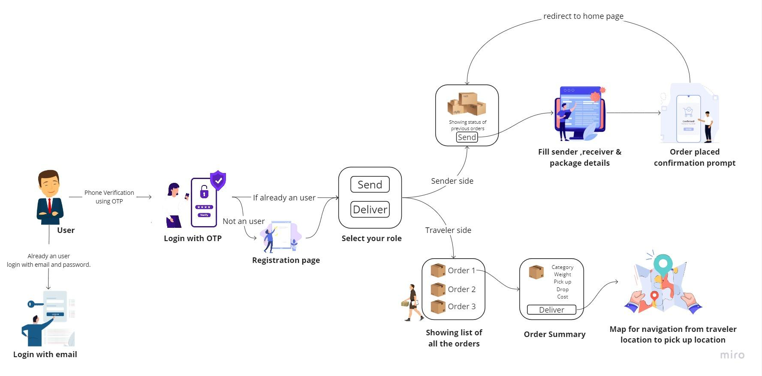

Figure 1: Block diagram

The block diagram represents the following:

1. User Interface: The "User Interface" block represents the point of entry for users. It includes login options with email and phone OTP for authentication. Additionally, there's a registration page where new users can sign up.
2. User Role Selection: After authentication or registration, users are directed to a role selection page. They can choose to register as a "Sender" or a "Traveler." This step determines the user's role within the application.
3. Sender's Role: If the user selects the "Sender" role, they are directed to a page where they can input package details. This includes information such as package dimensions, weight, contents, delivery location, and preferred delivery timeframe.
4. Traveler's Role: When users choose the "Traveler" role, they are presented with a list of available packages to deliver. This list is generated based on their travel plans and the compatibility of package destinations with their route and schedule.
5. Mapping Page: For travelers, there is an additional "Maps Page" that displays the routes, and locations of packages that need delivery. This page helps travelers visualize the delivery routes and select packages that align with their travel plans.

**4.2 Modular diagram of the system**

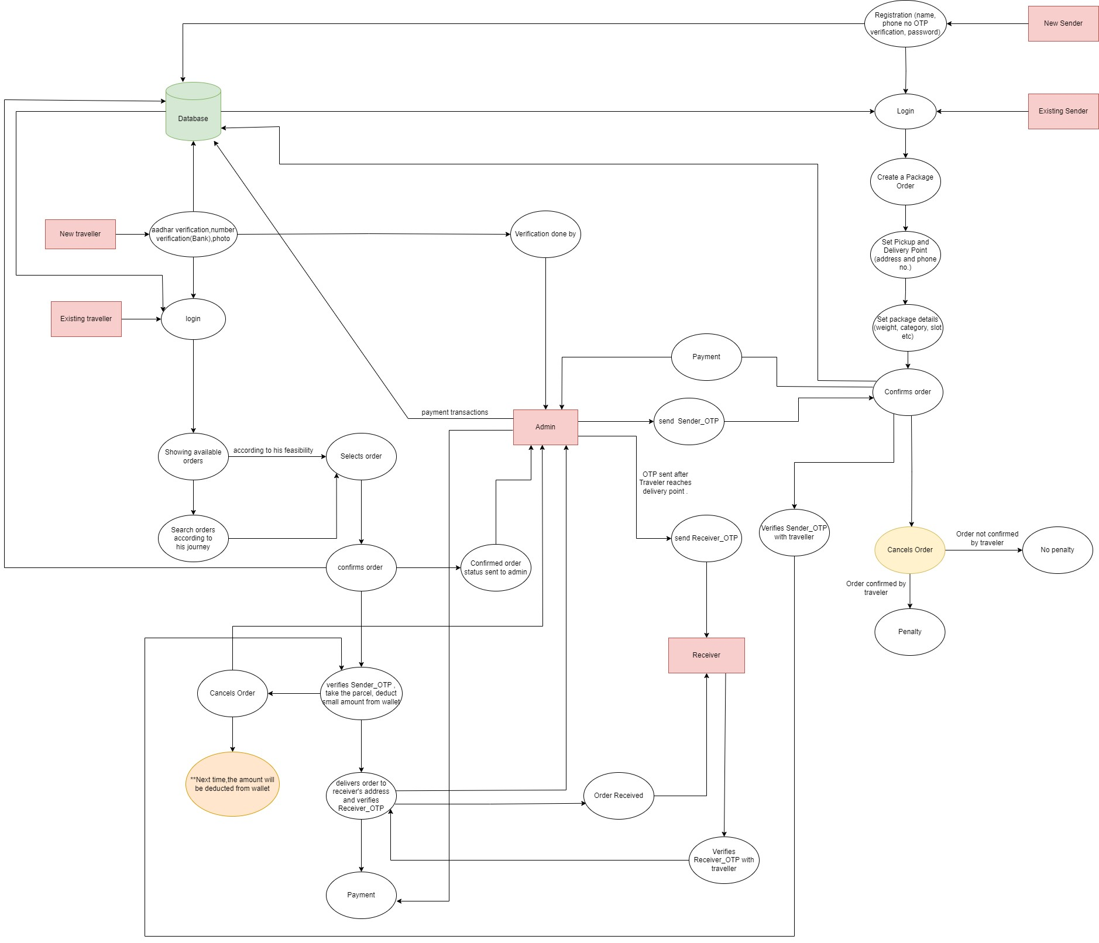

Figure 2: Modular diagram

**Sender Flow:**

Users first register on the platform and choose their role as either a sender or a traveler.

Senders can create a new package delivery order by providing the sender's and receiver's details.

They must also include specific package details and proceed to confirm the order by making a payment.

**Traveler Flow:**

Travelers must register on the platform, undergoing a KYC (Know Your Customer) process, and complete a face liveness detection step for identity verification.

Once registered, a traveler can accept an order for delivery at their convenience.

They receive an OTP/QR code, which they must verify at the sender's location before picking up the package.

After picking up the package, the traveler must verify the order again using the same OTP/QR code at the receiver's location before handing over the package.

Upon successful delivery, the system initiates the payment process, rewarding the traveler for their service.

**4.3 Detailed design**

1. **DFD Level 0**

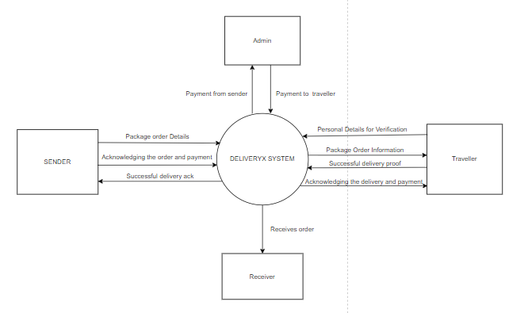

Figure 3: DFD Level 0

In the DFD Level 0, there are four primary entities: Admin, Sender, Traveler, and Receiver. The Admin oversees the entire system, managing user accounts, ensuring security, and monitoring transactions. Senders initiate package delivery requests, providing package details and recipient information. Travelers register their travel plans and accept delivery requests based on compatibility with their routes. They commit to transporting packages from senders to receivers during their journey. Receivers are the final recipients of the packages. The system connects senders with travelers, ensuring secure payments and transparent transactions. It facilitates the handover of packages and ensures successful delivery, promoting a collaborative and cost-effective package shipping solution.

1. **DFD Level 1**

In DFD Level 1, the system's functionality is further detailed:

Admin: The Admin entity manages user accounts and system configurations.It monitors user activities, addresses disputes, and oversees the overall system security and integrity.

Sender: Senders initiate package delivery requests by inputting package details.They choose delivery timeframes, make payments, and hand over packages to travelers or designated collection points.

Traveler: Travelers accept delivery requests based on their travel plans. They access package details and commit to delivering packages to the specified recipients.Travelers earn compensation upon successful delivery.

Receiver: Receivers are the final recipients of the packages. They confirm successful deliveries through the system, provide feedback, and rate the service.

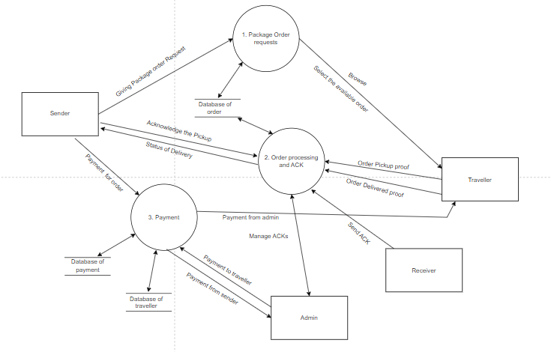

Figure 4: DFD Level 1

1. **Entity-Relationship diagram (ERD)**

**Entities:**

1. User: This entity represents all users of the application, including senders, travelers, and administrators. It stores user-specific data like usernames, contact information, and authentication credentials.
2. Package: The package entity stores information related to packages, such as dimensions, weight, contents, delivery details, and pricing.
3. Delivery Request: This entity records the requests made by senders for package deliveries. It links packages with travelers who accept the delivery requests.
4. Traveler Profile: Traveler profiles contain details about individuals who are willing to transport packages. These profiles include travel plans, destinations, and user-specific data.
5. Transaction: The transaction entity captures payment transactions between senders and the application, including payment details, amounts, and the escrow mechanism.

**Relationships:**

1. User-Role Relationship: This represents the connection between the "User" entity and the role they play, whether it's a sender, traveler, or administrator.
2. Package-User Relationship: This shows the association between packages and the users (senders and travelers) involved in a delivery.
3. Delivery Request-Package Relationship: This relates a delivery request with the package it pertains to.
4. Delivery Request-Traveler Relationship: It links delivery requests to travelers who accept them, indicating the assignment of packages for transportation.
5. Transaction-User Relationship: This depicts the connection between financial transactions and the users involved, including senders, travelers, and the application as an escrow agent.

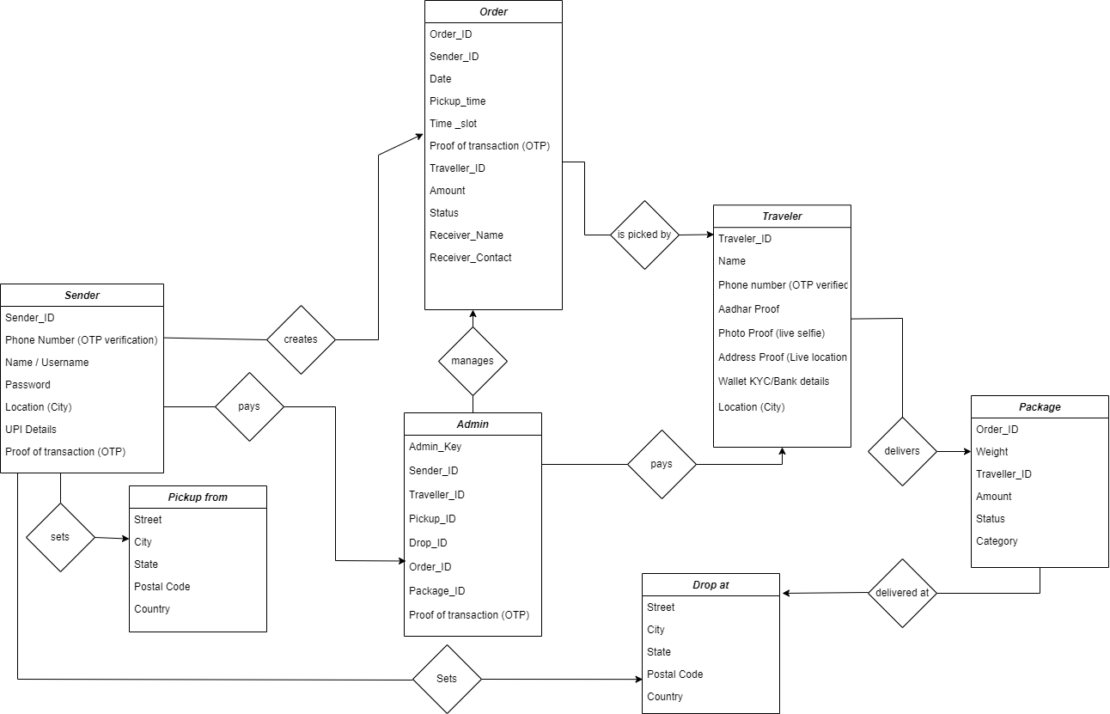

Figure 5: Entity-Relationship diagram (ERD)

**4.4 Project Scheduling and Tracking using Chart**

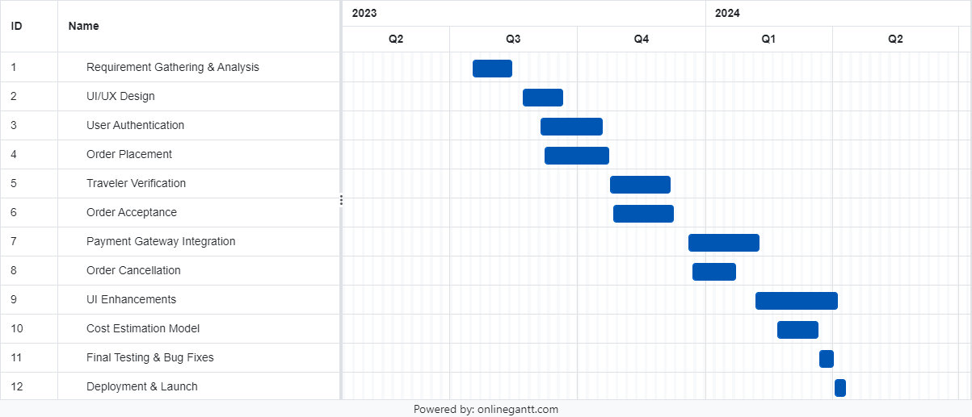

Figure 6: Gantt chart

The gantt chart visualizes the timeline of the different phases of the project, starting from defining the project scope till the completion of the project.

The development of a peer-to-peer delivery system encompasses several key stages. Beginning with a comprehensive research and planning phase, where the project scope and objectives are defined alongside market research and initial concept formulation, the project then transitions into a design phase aimed at crafting the user experience and interface. Subsequently, the development phase involves setting up the necessary backend infrastructure and frontend functionality, followed by rigorous testing and quality assurance procedures to ensure functionality and security. Deployment and launch mark the culmination of the project's initial phase, with ongoing post-launch support and maintenance essential for addressing user feedback and evolving market needs. Throughout this process, adherence to timelines and diligent project management are paramount for successful delivery.

**Chapter 5: Implementation of the proposed system**

**5.1 Methodology employed for development**

The methodology employed for the mobile application in the proposed solution to address the challenges of expensive and unreliable domestic package shipping is as follows:

1. Sender Creates Request: A sender initiates a package delivery request, providing package specifics and recipient details.
2. Traveler Reviews Package: Travelers review available delivery requests and opt for packages aligned with their travel route and schedule.
3. Traveler Accepts Request: Upon selecting a package, the traveler accepts the delivery request, confirming their commitment to transporting the package.
4. Secure Payment: The sender's payment is securely held by the app's administration until successful delivery, ensuring compensation for the traveler.
5. Package Delivery: The traveler collects the package from the sender, carries it during their journey, and delivers it to the recipient at the destination.

**5.2 Algorithms and flowcharts for the respective modules developed**

**5.2.1 Viola Jones Algorithm for Face Detection KYC**

The Viola-Jones algorithm is a popular face detection algorithm that uses Haar-like features, a cascading classifier, and integral images to efficiently detect faces in images. While it's primarily designed for face detection, it can be adapted for other object detection tasks, including traveler KYC (Know Your Customer) image detection, with appropriate training data and modifications.

1. Data Collection and Labeling:

* Gather a diverse dataset of traveler KYC images, including passports, ID cards, and other relevant documents.
* Carefully label each image to specify whether a KYC document is present or not.

1. Training the Cascade Classifier:

* Develop and train a cascade classifier using the labeled KYC image dataset.
* Customize Haar-like features to capture document-specific characteristics like text patterns, logos, or security features.

1. Integration with the Traveler KYC System:

* Integrate the trained algorithm into your traveler KYC system.
* Allow travelers to capture images of their documents, and apply the algorithm to automatically detect and validate KYC documents.

1. User Feedback and Verification:

* Implement a process to verify detected KYC documents against a database or external verification service.
* Communicate the verification status to the traveler for transparency and feedback.

1. Continuous Improvement and Compliance:

* Regularly update and retrain the algorithm with new KYC document samples to enhance accuracy and adapt to evolving document types.
* Adhere to strict privacy and security regulations while handling sensitive KYC documents to protect traveler data.

**5.2.2 System Flow**

1. **Order placement module**

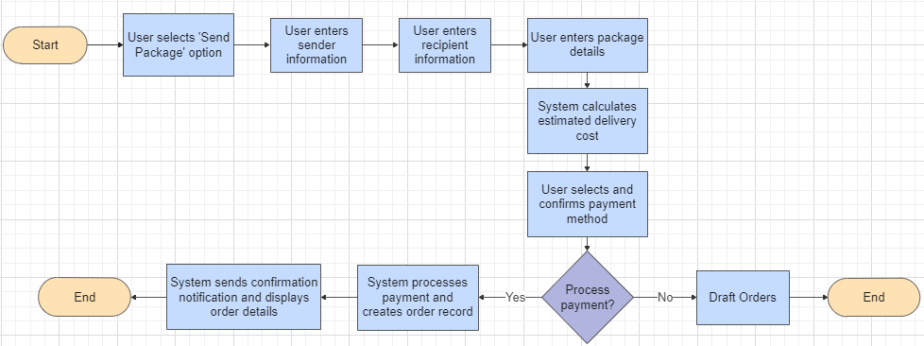

Figure 7: Order Placement

The flowchart in figure 7 depicts the following:

The user initiates by selecting the “Send Package” option.The user then enters sender, recipient information, and package details. The system calculates the estimated delivery cost and the user confirms the payment method. Finally, the system sends a confirmation notification, creates an order record, and the process ends.

1. **Traveler verification and order acceptance**

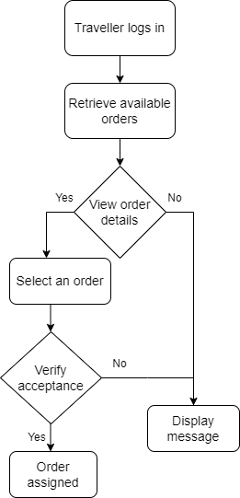

Figure 8: Order Acceptance

The flowchart in figure 8 demonstrates the following:

The traveler logs in to the system. The system retrieves a list of available orders for the traveler. The traveler selects an order and views its details. The traveler decides to accept or reject the order. If accepted, a message is displayed and the order is assigned to the traveler. If rejected, the process ends.

**Chapter 6: Testing of the proposed system**

**6.1 Introduction to testing**

Software testing is the sequence of activities that happen during software testing. By employing a sane software testing life cycle, an organization ends up with a quality strategy more likely to produce better results. Why is this so important, though? It all boils down to customer satisfaction. Presenting a perfect product to the customer is the end goal of every organization.

Nothing puts off customers more than bug-filled user experience. So when enterprises realized this, they began to include testing as a mandatory part of the SDLC. Since then, testing has become an integral part of every organization.

Project Testing Phase means a group of activities designated for investigating and examining progress of a given project to provide stakeholders with information about actual levels of performance and quality of the project. It is an attempt to get an independent view of the project to allow stakeholders to evaluate and understand potential risks of project failure or mismatch. The purpose of the testing phase is to evaluate and test declared requirements, features, and expectations regarding the project prior to its delivery in order to ensure the project matches initial requirements stated in specification documents.

**6.2 Types of tests considered**

Automated testing falls into a few categories:

* A unit test tests a single function, method, or class.
* A widget test (in other UI frameworks referred to as component test) tests a single widget.
* An integration test tests a complete app or a large part of an app.

A **unit test** tests a single function, method, or class. The goal of a unit test is to verify the correctness of a unit of logic under a variety of conditions. External dependencies of the unit under test are generally mocked out. Unit tests generally don’t read from or write to disk, render to screen, or receive user actions from outside the process running the test.

A **widget test** (in other UI frameworks referred to as component test) tests a single widget. The goal of a widget test is to verify that the widget’s UI looks and interacts as expected. Testing a widget involves multiple classes and requires a test environment that provides the appropriate widget lifecycle context.

For example, the Widget being tested should be able to receive and respond to user actions and events, perform layout, and instantiate child widgets. A widget test is therefore more comprehensive than a unit test.

An **integration test** tests a complete app or a large part of an app. The goal of an integration test is to verify that all the widgets and services being tested work together as expected. Furthermore, you can use integration tests to verify your app’s performance.

Generally, an integration test runs on a real device or an OS emulator, such as iOS Simulator or Android Emulator. The app under test is typically isolated from the test driver code to avoid skewing the results.

**6.3 Various test case scenarios considered**

**Test Cases:**

* OTP received:
  + Pass: User receives OTP promptly after request.
  + Fail: OTP delivery delayed or not received despite multiple attempts.
* Register as sender:
  + Pass: User successfully completes registration with valid information.
  + Fail: Registration fails due to invalid or incomplete information provided.
* Login as sender:
  + Pass: Sender logs in successfully with correct credentials.
  + Fail: Login attempt fails due to incorrect username or password.
* Place order:
  + Pass: Sender successfully places an order with all required details.
  + Fail: Order placement fails due to server error or incomplete information provided.
* View order (sender):
  + Pass: Sender can view their placed order details accurately.
  + Fail: Error occurs while attempting to view order details or details are not displayed correctly.
* Switch user:
  + Pass: User successfully switches between different user roles.
  + Fail: Switching user roles fails or leads to unexpected errors in application behavior.
* Login as traveler:
  + Pass: Traveler logs in successfully with correct credentials.
  + Fail: Traveler unable to login due to network issues or invalid login credentials.
* View order (traveler):
  + Pass: Traveler can view details of the assigned order accurately.
  + Fail: Traveler encounters error while trying to access order details or details are missing/incomplete.
* View order on map:
  + Pass: Traveler can see the location of the order accurately on the map.
  + Fail: Map fails to load or displays incorrect location for the order.
* Accept order:
  + Pass: Traveler successfully accepts the assigned order.
  + Fail: Accepting order fails due to server issues or conflicting orders.
* Order confirmation:
  + Pass: Confirmation message displayed upon successful order acceptance.
  + Fail: No confirmation message appears or confirmation message displays incorrect information.
* View directions on map:
  + Pass: Traveler can view accurate directions to the pickup and drop-off locations.
  + Fail: Directions fail to load or display inaccurate routes.
* Scan QR (traveler):
  + Pass: Traveler successfully scans the QR code for order verification.
  + Fail: QR code scan fails to validate the order or encounters technical issues.
* View QR (sender):
  + Pass: Sender can view the QR code associated with the order.
  + Fail: QR code fails to display or appears distorted, hindering sender's ability to share it.
* Get OTP (receiver):
  + Pass: Receiver receives OTP promptly for verification.
  + Fail: OTP delivery to receiver delayed or not received despite multiple attempts.
* Verify OTP (traveler):
  + Pass: Traveler successfully verifies OTP for order confirmation.
  + Fail: OTP verification fails, preventing traveler from confirming the order.

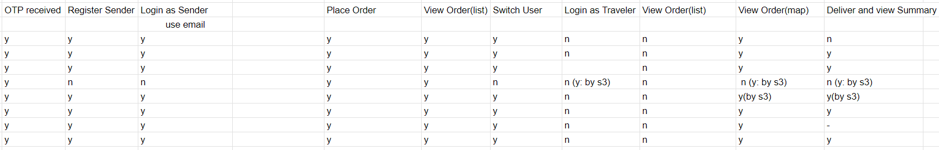

Figure 9 : Manual Test Cases : Order Placing Phase

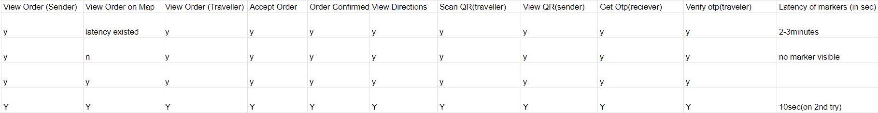

Figure 10 : Manual Test Cases : Order Acceptance Phase

**6.4 Inference drawn from test cases**

1. Test Coverage Analysis: Assess the extent of test coverage achieved by both manual and automated tests. This includes identifying areas of the app that are thoroughly tested and those that may require additional testing efforts.
2. Bug Identification and Prioritization: Detection of bugs or issues through both manual exploration and automated test scripts. Prioritize bugs based on severity, frequency of occurrence, and impact on user experience.
3. Efficiency of Testing: Evaluate the efficiency of automated testing in terms of time saved compared to manual testing. Identify repetitive test cases that can be automated to streamline the testing process.
4. Feedback Incorporation: Integrate feedback from manual testing sessions into the automated test suite. Update automated test scripts to cover newly identified test scenarios and edge cases based on manual testing insights.
5. User Experience Validation: Combine manual exploratory testing with automated UI testing to validate the user experience across different devices and screen sizes. Identify UI inconsistencies and usability issues that may impact user satisfaction.

**Chapter 7: Results and Discussion**

**7.1 Screenshots of UI for the respective module**

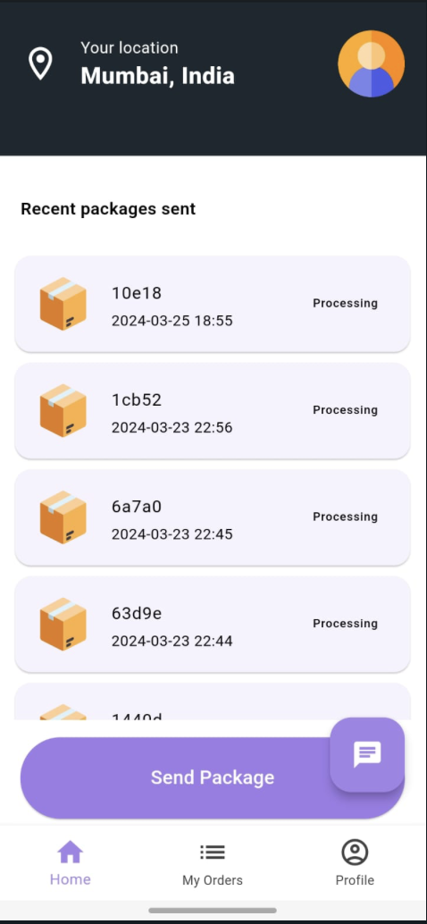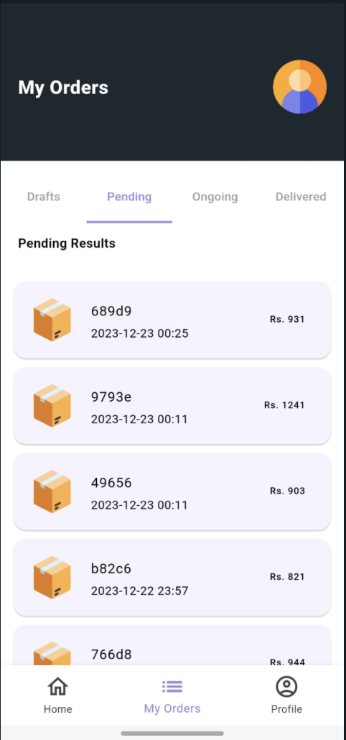

Splash Screen Sender Homepage My Order Page

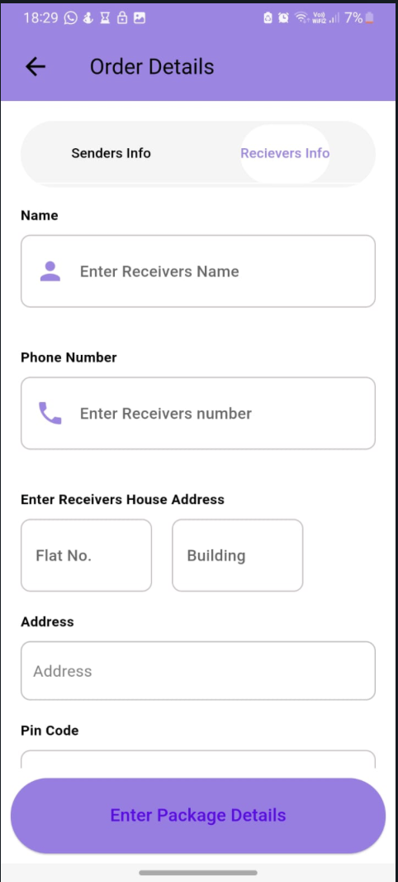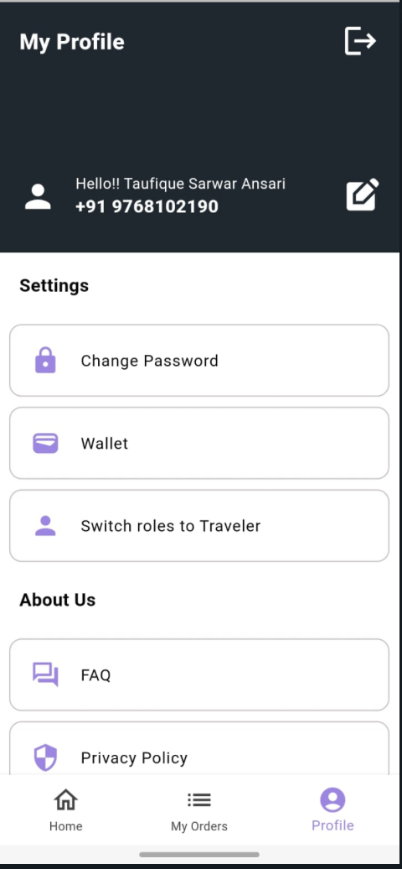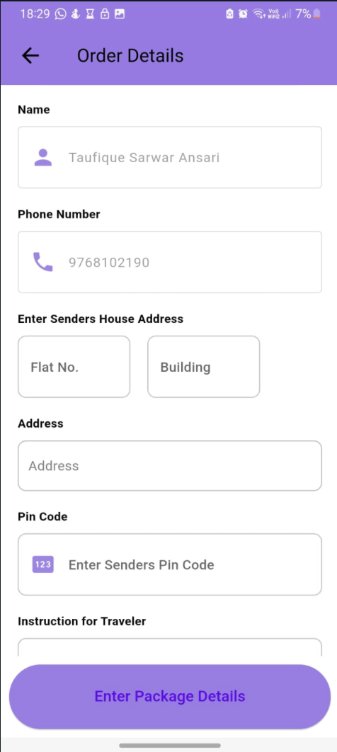

Receiver Details Page Profile Page Sender Details Page

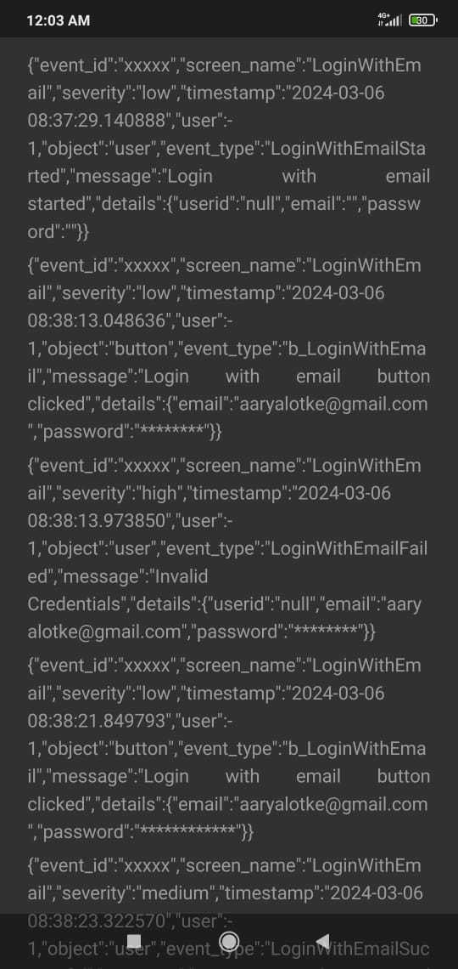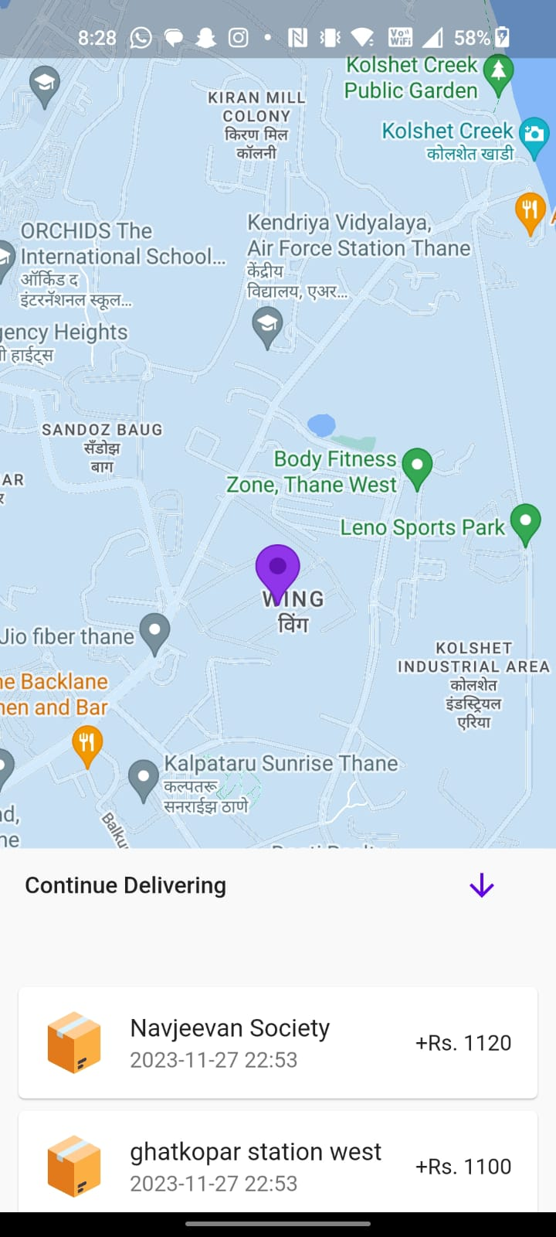

Event Logs Multiple Orders Page

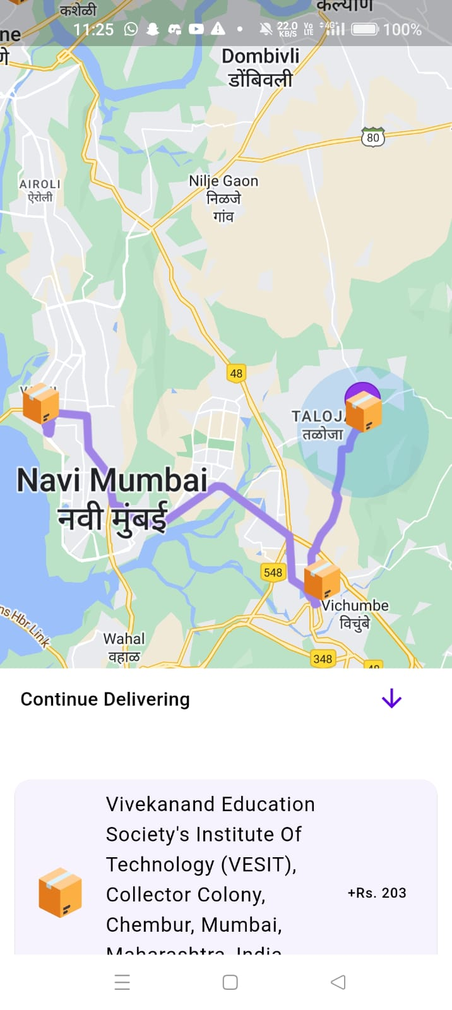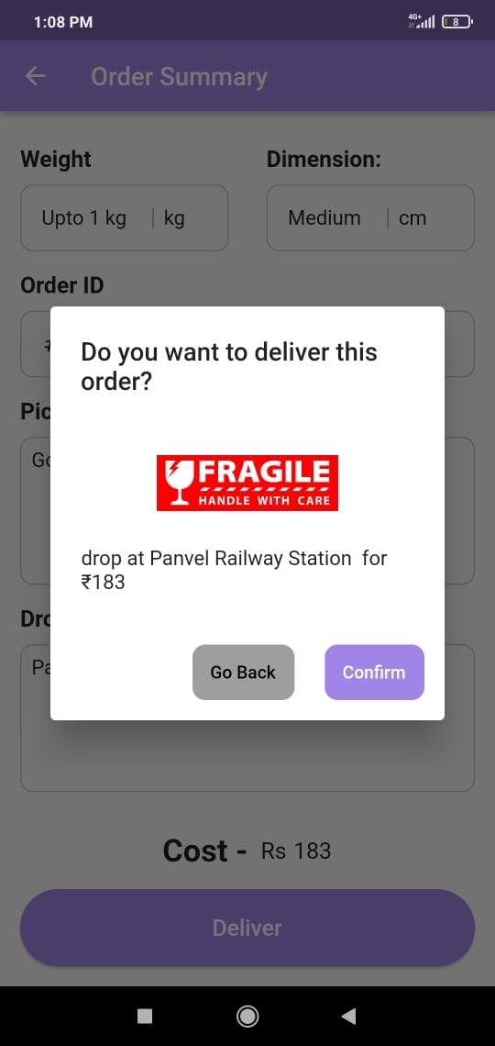

Routes Page Fragile Item Prompt

**7.2 Performance evaluation measures**

1. **Response Time:** The average time taken by the app to respond to user actions such as order placement, order acceptance, and tracking updates.
2. **Throughput:** The number of transactions (orders placed, orders accepted, deliveries completed) processed by the app per unit time, indicating its efficiency in handling concurrent requests.
3. **Error Rate:** The frequency of errors encountered by users during app usage, including authentication failures, payment processing errors, and order tracking discrepancies.
4. **User Satisfaction:** Feedback gathered from users regarding their overall satisfaction with the app's performance, ease of use, and reliability.

**7.3 Input parameters / Features considered**

**1. User Authentication Mechanisms:**

**Efficiency and Security:**

- Email Verification: When users register on DeliveryX, they are required to provide their email addresses. An email verification mechanism sends a confirmation link to the provided email address, ensuring that the user is authentic. This process is efficient as it verifies the user's identity quickly, and it enhances security by preventing unauthorized access.

- OTP Verification: In addition to email verification, DeliveryX employs OTP (One-Time Password) verification for added security. Users receive a unique OTP on their registered mobile numbers, which they need to enter during the registration or login process. This method enhances security by adding an extra layer of authentication, ensuring that only the rightful user can access their account.

- KYC Processes: For travelers interested in delivering parcels, a Know Your Customer (KYC) process is implemented. This involves submitting identification documents such as Aadhar cards and a live selfie for verification. KYC adds another level of security by verifying the identity of the traveler, thereby building trust among users and ensuring the authenticity of delivery personnel.

**2. Order Placement Process:**

**Ease and Speed:**

-Entering Sender/Receiver Details: The order placement process on DeliveryX is designed to be intuitive and straightforward. Users can easily input sender and receiver details, including addresses and contact information, through a user-friendly interface. This ensures that the process is quick and efficient, requiring minimal effort from the user.

- Package Information: Users can provide detailed information about the package they wish to send, including dimensions, weight, and any special instructions. This ensures that senders can accurately convey the requirements of their delivery, leading to a smoother transaction process.

- Selecting Payment Methods: DeliveryX offers multiple payment methods, including credit/debit cards, net banking, and digital wallets. Users can choose their preferred payment method during the order placement process, providing flexibility and convenience. Integration with secure payment gateways ensures that transactions are processed swiftly and securely, enhancing user satisfaction.

**3. Traveler Verification and Order Acceptance:**

**Effectiveness and Convenience:**

- Traveler Verification: The traveler verification process involves submitting identification documents and undergoing a KYC process, as mentioned earlier. This ensures that only legitimate individuals are allowed to participate as delivery personnel, enhancing trust and security within the platform.

- Viewing and Accepting Delivery Requests: Travelers can easily view available delivery requests in their vicinity through the app. The interface provides clear information about each request, including sender/receiver details, package information, and estimated delivery fees. Travelers can then choose to accept or reject delivery requests based on their availability and commuting route, providing flexibility and convenience.

**4. Order Tracking and Delivery:**

**Accuracy and Timeliness:**

- Real-Time Location Updates: DeliveryX offers real-time tracking of parcels from pickup to delivery. Both senders and recipients can track the exact location of their parcels through the app, providing transparency and peace of mind. Timely updates ensure that users are informed about the status of their deliveries, reducing anxiety and uncertainty.

- Delivery Status Notifications: Users receive timely notifications about the status of their deliveries, including pickup confirmation, transit updates, and delivery confirmation. These notifications are sent via push notifications, SMS, or email, depending on user preferences. Clear and concise communication ensures that users stay informed throughout the delivery process, enhancing their overall experience.

By focusing on efficient and secure user authentication mechanisms, streamlining the order placement process, ensuring effective traveler verification and order acceptance, and providing accurate and timely tracking updates, DeliveryX aims to deliver a seamless and satisfying experience for both senders and travelers

**7.4 Graphical and statistical output**

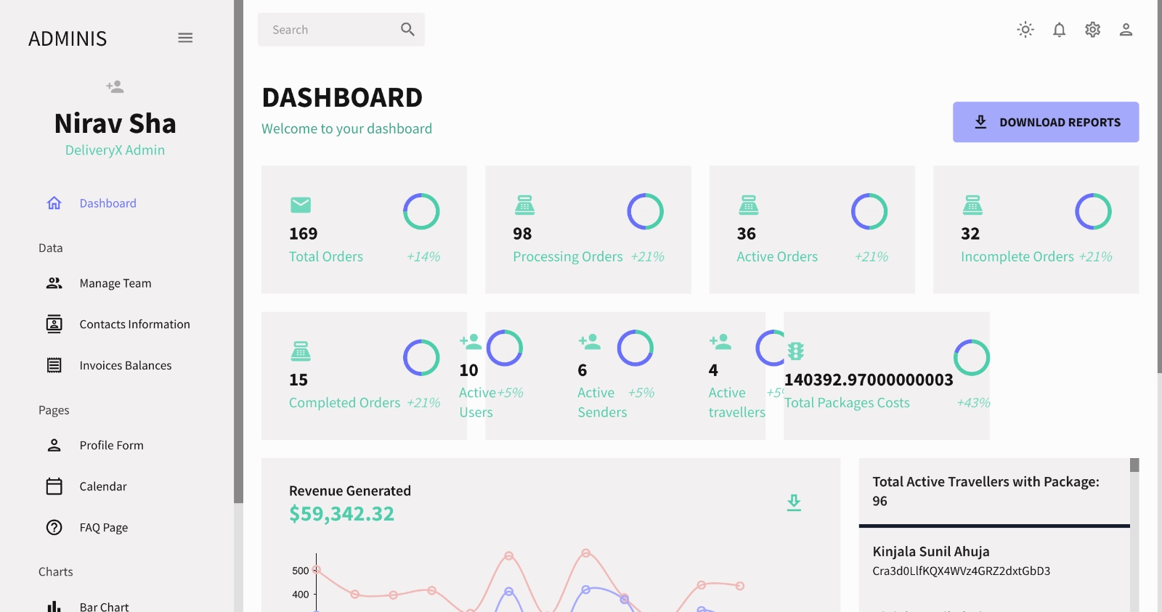

Figure 11: Admin dashboard: Home Page

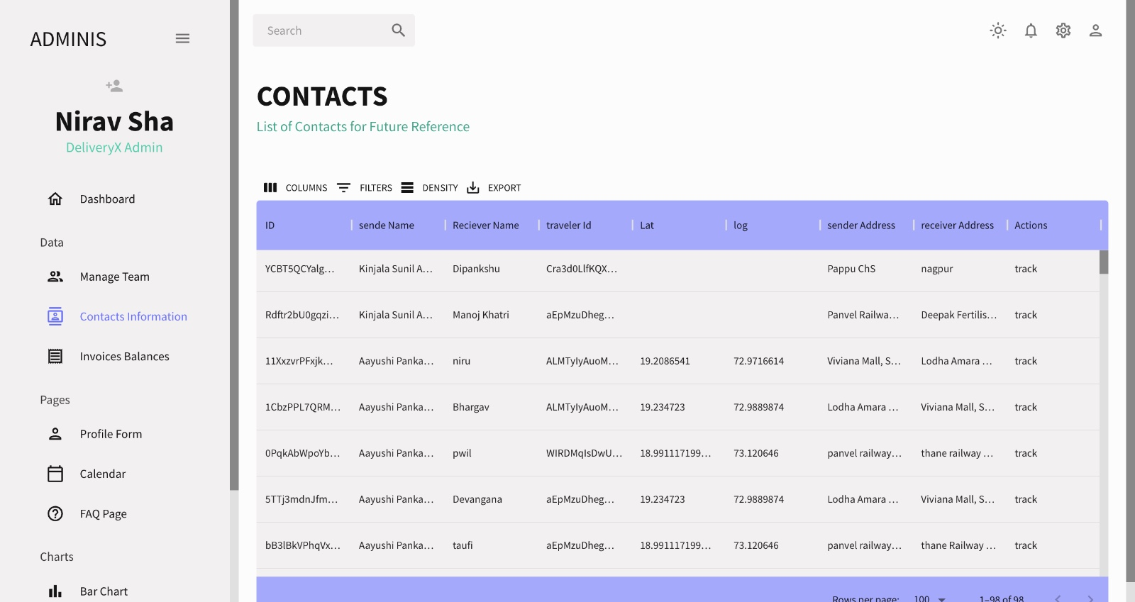

Figure 12: Admin dashboard - List of contacts

**Admin dashboard:** The admin dashboard serves as the central control hub, facilitating efficient management and oversight of various aspects of the system or application. Real-time data retrieval from Firebase Firestore enhances its functionality, providing administrators with instant access to critical information.

The admin panel empowers administrators to interact with the data, allowing them to filter, sort, and drill down to uncover insights. They can take immediate action, such as managing user accounts or moderating content, directly from the dashboard.

**Statistics:**

* Total orders
* Processing orders
* Active orders
* Incomplete orders
* Completed orders
* Active users
* Active senders
* Active travelers

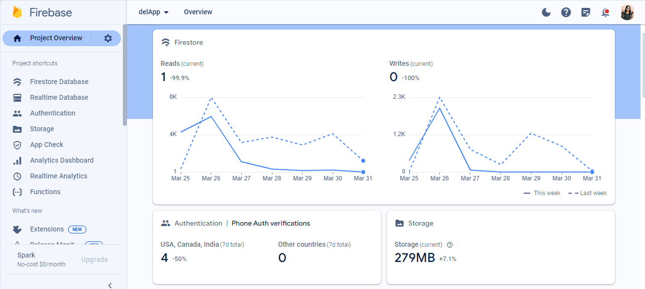

Figure 13 : Firestore Statistics

The Firebase Firestore project overview read/write graph illustrates the flow of data within the database, mapping out the frequency and distribution of read and write operations across various collections and documents. This graph serves as a diagnostic tool for developers and administrators to analyze database usage patterns and identify areas for improvement.

**7.5 Comparison of results with existing systems**

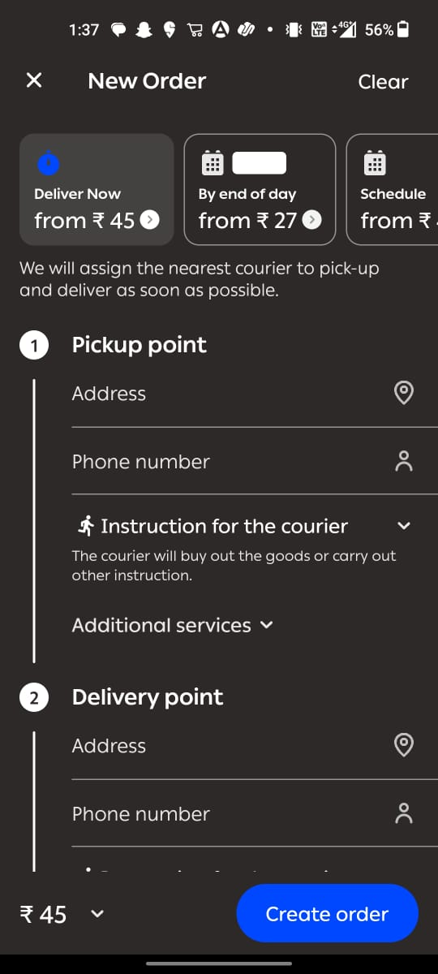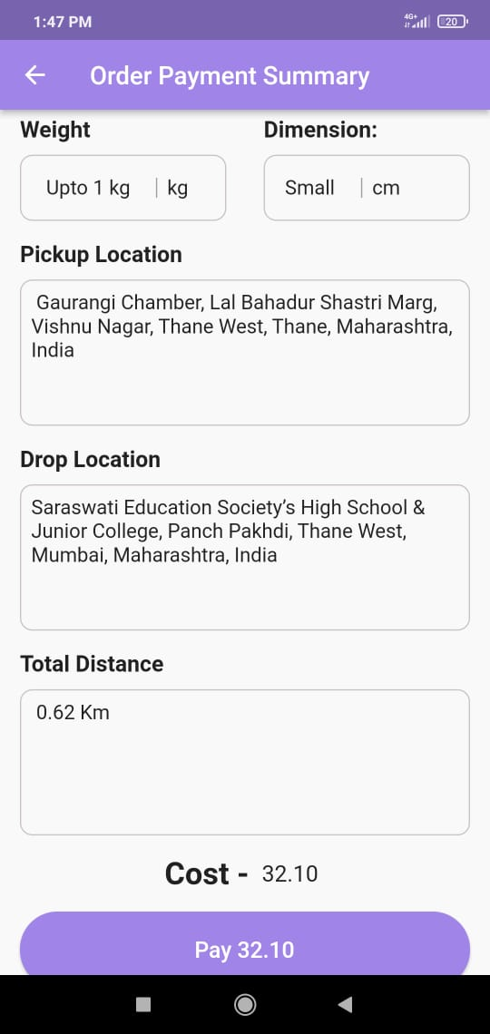

**Source: Borzo Delivery App Payment Summary Page**

**Comparison:**

**Pricing Discrepancy:**

In the first image, the delivery price displayed on Borzo is Rs. 45 for the same distance and type of package.

However, in the second image, the delivery price shown on our application is significantly lower, at Rs. 32, for an identical service.

**Competitive Advantage:**

Our application offers a more competitive pricing structure compared to Borzo, as evidenced by the lower delivery fee.

This price difference could attract potential customers who seek affordable delivery options, potentially giving our application a competitive edge in the market.

**7.6 Inference drawn**

1. **Technical Efficiency:**

DeliveryX demonstrates robust technical performance, with fast response times, high throughput, and low error rates.

1. **User Satisfaction:**

The app's intuitive design, efficient functionality, and reliable performance contribute to high levels of user satisfaction.

1. **Competitive Advantage:**

DeliveryX offers distinct advantages over existing systems in terms of performance, reliability, and user experience, positioning it as a leading solution in the parcel delivery market.

**Chapter 8: Conclusion**

**8.1 Limitations**

* **Geographical Constraints:** Initially, the service may be limited to urban areas with a dense population to ensure an adequate pool of travelers for parcel delivery. Expanding to rural areas may pose logistical challenges.
* **Network Connectivity:** The app's functionality heavily relies on network connectivity, making it susceptible to disruptions in areas with poor network coverage.
* **Regulatory Compliance:** Compliance with local regulations regarding parcel delivery, data protection, and transportation is imperative and may vary across different regions.
* **Trust and Security Concerns:** Establishing trust among users and ensuring the security of transactions and personal information are critical challenges that require ongoing vigilance and improvement.

**8.2 Conclusion**

The project sets out to revolutionize domestic parcel shipping by engaging travelers or individuals heading in the same direction, promising reduced costs and an expanded courier network. This approach tackles critical issues in both local and international shipping, making services more accessible and economically viable. By lowering the financial burden associated with shipping, it not only benefits users but also stimulates business activities and enhances trade, fostering economic growth.

Furthermore, the project's commitment to environmental sustainability is crucial in today's context, where reducing carbon emissions is paramount. By optimizing resource utilization and minimizing the number of dedicated delivery vehicles on the road, it contributes to a greener, more sustainable future. This resource efficiency, coupled with the utilization of underutilized cargo space in vehicles, not only drives down costs but also aligns with principles of sustainability, offering a holistic solution to shipping challenges.

In conclusion, this project offers a comprehensive solution to domestic and international parcel shipping challenges. With its potential to lower costs, enhance environmental sustainability, optimize resources, and empower local communities, it holds promise as a transformative initiative that could reshape the future of parcel shipping services. Its adaptability to international shipping needs further underscores its potential for global impact and scalability, making it a significant endeavor in the evolution of shipping logistics.

**8.3 Future scope**

* **Enhanced Geographic Coverage:** Expanding the service to cover a wider geographical area, including rural regions, to cater to a broader user base.
* **Integration of Additional Features:** Incorporating features such as parcel insurance, same-day delivery options, and customizable delivery preferences to enhance user experience and meet evolving market demands.
* **Partnerships and Collaborations:** Forming strategic partnerships with e-commerce platforms, local businesses, and logistics companies to strengthen the delivery network and reach new customer segments.
* **International Expansion:** Exploring opportunities for international expansion to tap into global markets and facilitate cross-border parcel delivery.
* **Continuous Improvement:** Continuously gathering user feedback, monitoring market trends, and iterating on the platform to address emerging challenges and stay ahead of the competition.

**References**

[1] Snodgrass, Kellye. “Common Package Delivery Problems and How to Solve Them?” PackageX, 8 September 2021, https://packagex.io/blog/package-delivery. Accessed 6 August 2023.

[2] Sayed Ahmed, Saif Eddin. (2020). Critical Reflections on the Strategic Management of FedEx Corporation.

[3] Chang TS,Yen HM. City-courier routing and scheduling problems. Eur J Oper Res. 2012 Dec; 223(2):489–98

[4] Arpita Mukherjee & Atul Sanganeria & Ramneet Goswami, 2023. "Express Delivery Services: Supporting the Journey Towards India@2047," Indian Council for Research on International Economic Relations (ICRIER) Report 23-r-02

[5] Saxena, Anupriya. (2019). An Analysis of Online Food Ordering Applications in India: Zomato and Swiggy.

[6] Ahmed, J. U., Ahmed, A., Faroque, A. R., & Fatema, K. (2022). Papers N Parcels: Fill the gap by an app–teenager created initiatives in courier service. Journal of Information Technology Teaching Cases, 0(0).

[7] Ghajargar, Maliheh & Zenezini, Giovanni & Montanaro, Teodoro. (2016). Home delivery services: innovations and emerging needs. IFAC-PapersOnLine. 49. 1371-1376. 10.1016/j.ifacol.2016.07.755.

[8] Ghajargar, Maliheh & Zenezini, Giovanni & Montanaro, Teodoro. (2016). Home delivery services: innovations and emerging needs. IFAC-PapersOnLine. 49. 1371-1376. 10.1016/j.ifacol.2016.07.755.

[9] Ramesh, R. & Prabhu S, Venkatesa & Sasikumar, Bashyam & Devi, B.S. & Prasath, P. & Kamala, S.. (2021). An empirical study of online food delivery services from applications perspective. Materials Today: Proceedings. 80. 10.1016/j.matpr.2021.05.500.

[10] Roselle Salazar Solitario, "Fake Delivery Bookings In Context-Aware Food Delivery Systems: A Literature And Mobile Apps Review", 2021 1st International Conference in Information and Computing Research (iCORE), pp.1-5, 2021.

[11] L. C. Laoh, T. Adithia Pongantung and C. Mulalinda, "Android Application Food Delivery Services," 2020 2nd International Conference on Cybernetics and Intelligent System (ICORIS), Manado, Indonesia, 2020, pp. 1-6, doi: 10.1109/ICORIS50180.2020.9320843.

[12] S. Mahamad, S. Sulaiman and W. Y. Leng, "An Integrated Courier Services Application: A New User Experience," 2018 IEEE Conference on e-Learning, e-Management and e-Services (IC3e), Langkawi, Malaysia, 2018, pp. 161-166, doi: 10.1109/IC3e.2018.8632652.

[13] M. A. Talib, A. Colman, J. Han, J. King and M. Kapuruge, "A Service Packaging Platform for Delivering Services," 2010 IEEE International Conference on Services Computing, Miami, FL, USA, 2010, pp. 202-209, doi: 10.1109/SCC.2010.60.

[14] A. Shamsuzzoha, R. Addo-Tenkorang, D. Phuong and P. Helo, "Logistics tracking: An implementation issue for delivery network," 2011 Proceedings of PICMET '11: Technology Management in the Energy Smart World (PICMET), Portland, OR, USA, 2011, pp. 1-10.

[15] U. Janjarassuk and R. Masuchun, Cost and reliability analyses for the vehicle routing problem, in 2017 14th International Conference on Electrical Engineering/Electronics, Computer, Telecommunications and Information Technology (ECTI-CON), June 2017, pp. 338–341.

[16] Kidwai, Ahmad Ghazali & Maqbool², Adeel. (2023). RECENT DEVELOPMENTS IN COURIER SERVICES : A REVIEW. 5. 1742-1758.

**Appendix**

1. **Proposed Patent**



**Introduction :**

In modern logistics, efficient and secure package handling is essential. The proposed invention introduces a novel system that combines the functionalities of an ATM, locker, and package scanner. This system streamlines the process of package submission, screening, storage, and retrieval while ensuring security and accuracy.In modern logistics, efficient and secure package handling is essential. The proposed invention introduces a novel system that combines the functionalities of an ATM, locker, and package scanner.

At its core, the proposed invention is designed to simplify and expedite the intricate process of package submission, screening, storage, and retrieval. Unlike conventional methods that often involve multiple stages and handoffs between various stakeholders, this integrated system consolidates these functions into a single, cohesive platform. By leveraging cutting-edge technology and automation, it eliminates bottlenecks, reduces human error, and enhances overall operational efficiency.

1. **Competition Certificates**









1. **Project review sheet**

Review Sheet 1

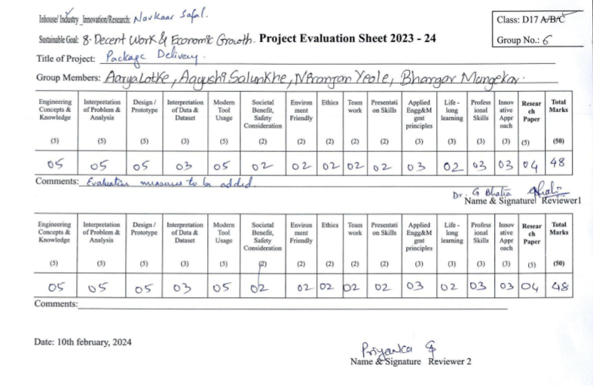

Review Sheet 2

